ASR [6843](javascript:showDets('6843',%20'Open');) – CHINA WO Label:

Changes:

1. Require 2nd expiry date capture in WO ( expiry date – SP)
2. Require change on Qty Order ( uom ) and Qty Breakdown UOM

>> Detail:

**From:** Kio, Xi Xiang   
**Sent:** Monday, 30 October, 2017 4:43 PM  
**To:** Chan, Pei-Fong  
**Cc:** Tat Shin, Vun; Rahamat, Mohd Syaiful Adli; Jack, Fong; Kok_Hao_Ang; Tan, Wee Jian  
**Subject:** RE: China WO go live

Hi Pei Fong,

After discussion with customer, instead of Mfg Date (1) and Mfg Date (2), we will indicate as Mfg Date (SP) and Mfg Date (CAS)

**For SKU 446255:**

|  |  |  |  |  |  |  |  |  |  |  |
| --- | --- | --- | --- | --- | --- | --- | --- | --- | --- | --- |
| Imp License # | : NR |  | Mfg Date (SP) | : 2016-02 |  | Exp Date (SP) | : 2017-12 |  | MRP Rs Price | : NR |
| Regulated | : NR |  | Mfg Date (CAS) | : 2016-05 |  | Exp Date (CAS) | : 2018-02 |  | Imp Date | : NR |

**For others :**

|  |  |  |  |  |  |  |  |  |  |  |
| --- | --- | --- | --- | --- | --- | --- | --- | --- | --- | --- |
| Imp License # | : NR |  | Mfg Date (SP) | : NR |  | Exp Date (SP) | : NR |  | MRP Rs Price | : NR |
| Regulated | : NR |  | Mfg Date (CAS) | : 2016-02 |  | Exp Date (CAS) | : 2017-12 |  | Imp Date | : NR |

Only China Labeling SKU 446255 will require all 4 fields: Mfg date (SP), Mfg Date (CAS), Exp Date (SP), Exp Date (CAS).

All other labeling orders for China & India (including bundling orders) will only require Mfg date (CAS) & Exp Date (CAS).

Hence we will need your help to update:

* Work Order Traveller Form (F-LOG-BD-032)
* Rename WMS master “manufacturing date” to “manufacturing date (CAS)”
* Rename WMS master “expiry date” to “expiry date (CAS)”
* Update WMS master to include 2 new columns, namely manufacturing date (SP) and expiry date (SP).
* To clarify, below is applicable to China Labeling only.

For part no. 446255, UOM for order qty should be in SP, UOM for qty breakdown should be in CAS.  (Convert SP to CAS is simply divide by 10)

For all other part nos, UOM for order qty is in CAS, UOM for qty breakdown is NR (Not Required).

WMS Changes:

2017-11.07

# SKU Work Order

* Added:
* Expiry Date flag (CAS) – current expiry date flag
* Expiry Date flag (PS) – new expiry date flag

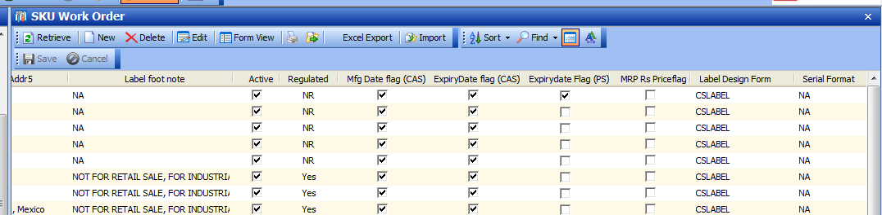

* UOM Order qty – new field
* UOM Breakdown qty - New field

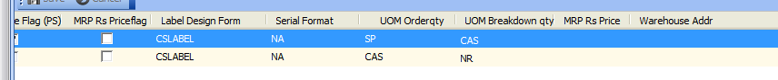

# SKU Batch Inventory

Current Manufacturing date change to “Manufacturing (CAS)

Expiry Date change to “Expiry Date (CAS)

Added new – Manufacturing Date (PS),

* + Expiry Date (PS

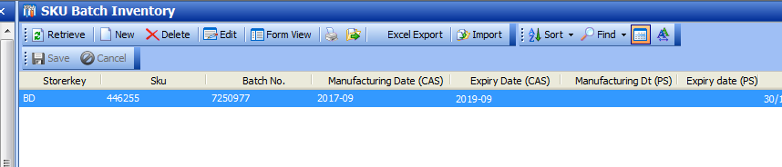

# WO generate

Validate Expiry date PS is required:

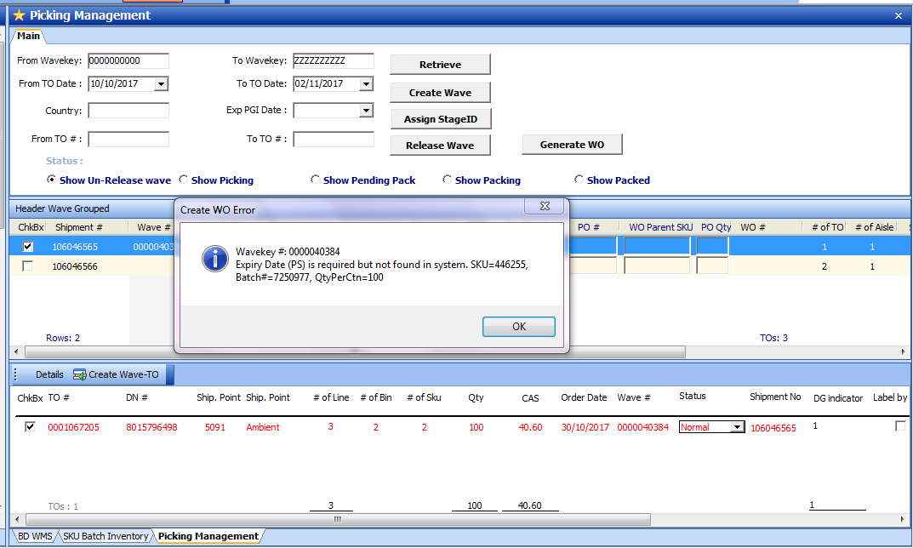

Update SKU Batch>

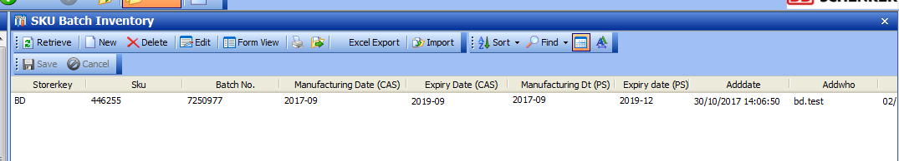

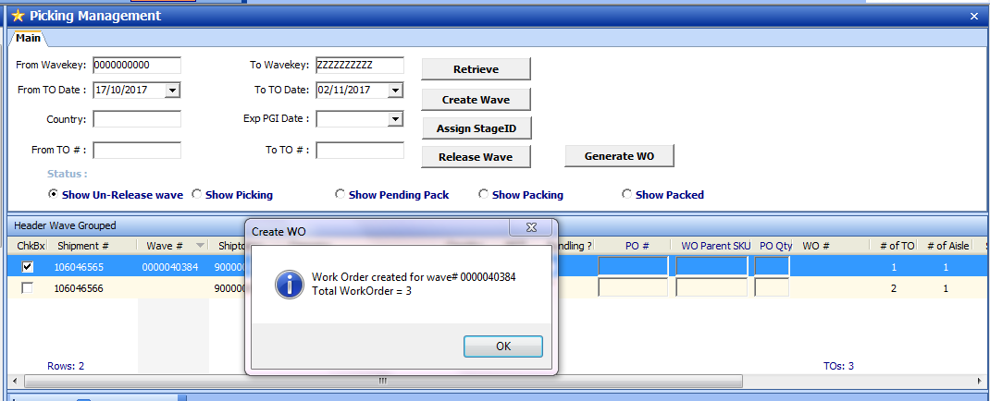

WO Traveller

* CN – SKU **446255**

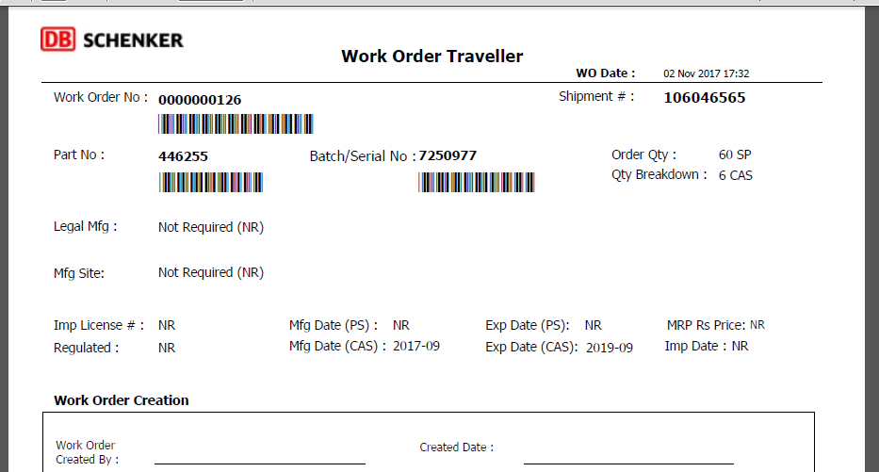

CN – others

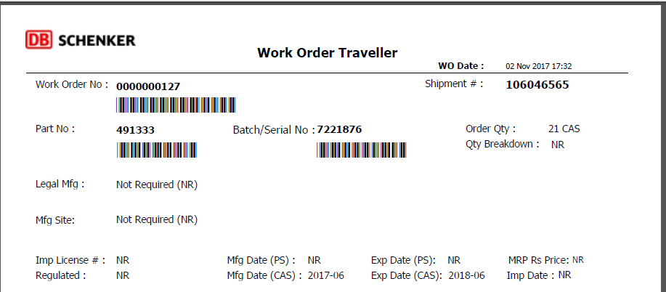

India Label

